**DAYANANDA SAGAR COLLEGE OF ENGINEERING**

Accredited by National Assessment & Accreditation Council (NAAC) with ’A’ Grade

*(AICTE Approved, an Autonomous Institute Affiliated to VTU, Belagavi)*

Shavige Malleshwara Hills, Kumaraswamy Layout, Bengaluru-560078

**DEPARTMENT OF MECHANICAL ENGINEERING**

**(Accredited by NBA)**



**A Mini-Project Report on**

**Design Of Automatic Fire Extinguisher System for Electric Vehicles**

*Submitted in partial fulfilment for the award of degree of*

**BACHELOR OF ENGINEERING**

In

**MECHANICAL ENGINEERING**

*2022-2023*

*Submitted by*

|  |  |
| --- | --- |
| **1DS20ME032** | **Himanshu Jha** |
| **1DS21ME435** | **Milan Sonnad** |
| **1DS21ME436** | **Mohammed Saqhib** |
| **1DS21ME437** | **Mohammed Hussain Khan** |

*Under the guidance of*

**Dr. P Sudhakar**

**Asst. Professor**

Department of Mechanical Engineering,

Dayananda Sagar College of Engineering

Shavige Malleshwara Hills, Kumaraswamy Layout, Bengaluru-560078

**DAYANANDA SAGAR COLLEGE OF ENGINEERING**

Accredited by National Assessment & Accreditation Council (NAAC) with ’A’ Grade

*(AICTE Approved, an Autonomous Institute Affiliated to VTU, Belagavi)*

Shavige Malleshwara Hills, Kumaraswamy Layout, Bengaluru-560078

**DEPARTMENT OF MECHANICAL ENGINEERING**

**(Accredited by NBA)**



***Certificate***

Certified that the project report entitled **‘Design Of Automatic Fire Extinguisher System for Electric Vehicles’** is a Bonafide work carried out by **Milan Sonnad** (**1DS21ME435)**, **Mohammed Hussain Khan (1DS21ME436)**, **Mohammed Saqhib** (**1DS21ME437)**, **Himanshu Jha (1DS20ME032)**, under the guidance of **Dr. P Sudhakar**, **Assistant Professor** Department of Mechanical Engineering, Dayananda Sagar College of Engineering, Bengaluru, in partial fulfillment for the award of Bachelor of Engineering in Mechanical Engineering of the Visvesvaraya Technological University, Belagavi.

**Dr. P Sudhakar**

Asst. Professor

Department of Mechanical Engineering

Dayananda Sagar College of Engineering.

Bengaluru

SL.NO. Name of the Examiner Signature with DateDr Aruna Devi

Assistant Professor, Dept. of Mech. Engg

Dayananda Sagar College of Engineering.

Bengaluru

SL.NO. Name of the Examiner Signature with Date

SL.NO. Name of the Examiner Signature with DateDr Aruna Devi

Assistant Professor, Dept. of Mech. Engg

Dayananda Sagar College of Engineering.

Bengaluru

SL.NO. Name of the Examiner Signature with DateDr Aruna Devi

Assistant Professor, Dept. of Mech. Engg

Dayananda Sagar College of Engineering.

Bengaluru

SL.NO. Name of the Examiner Signature with Date

SL.NO. Name of the Examiner Signature with Date

SL.NO. Name of the Examiner Signature with Date

SL.NO. Name of the Examiner Signature with DateDr Aruna Devi

Assistant Professor, Dept. of Mech. Engg

Dayananda Sagar College of Engineering.

Bengaluru

SL.NO. Name of the Examiner Signature with DateDr Aruna Devi

Assistant Professor, Dept. of Mech. Engg

Dayananda Sagar College of Engineering.

Bengaluru

SL.NO. Name of the Examiner Signature with Date

SL.NO. Name of the Examiner Signature with DateDr Aruna Devi

Assistant Professor, Dept. of Mech. Engg

Dayananda Sagar College of Engineering.

Bengaluru

SL.NO. Name of the Examiner Signature with DateDr Aruna Devi

Assistant Professor, Dept. of Mech. Engg

Dayananda Sagar College of Engineering.

Bengaluru

SL.NO. Name of the Examiner Signature with Date

SL.NO. Name of the Examiner Signature with Date

SL.NO. Name of the Examiner Signature with Date

SL.NO. Name of the Examiner Signature with Date

SL.NO. Name of the Examiner Signature with Date

SL.NO. Name of the Examiner Signature with Date

SL.NO. Name of the Examiner Signature with Date

SL.NO. Name of the Examiner Signature with DateDr Aruna Devi

Assistant Professor, Dept. of Mech. Engg

Dayananda Sagar College of Engineering.

Bengaluru

SL.NO. Name of the Examiner Signature with DateDr Aruna Devi

Assistant Professor, Dept. of Mech. Engg

Dayananda Sagar College of Engineering.

Bengaluru

SL.NO. Name of the Examiner Signature with Date

SL.NO. Name of the Examiner Signature with DateDr Aruna Devi

Assistant Professor, Dept. of Mech. Engg

Dayananda Sagar College of Engineering.

Bengaluru

SL.NO. Name of the Examiner Signature with DateDr Aruna Devi

Assistant Professor, Dept. of Mech. Engg

Dayananda Sagar College of Engineering.

Bengaluru

SL.NO. Name of the Examiner Signature with Date

SL.NO. Name of the Examiner Signature with Date

SL.NO. Name of the Examiner Signature with Date

SL.NO. Name of the Examiner Signature with DateDr Aruna Devi

Assistant Professor, Dept. of Mech. Engg

Dayananda Sagar College of Engineering.

Bengaluru

SL.NO. Name of the Examiner Signature with DateDr Aruna Devi

Assistant Professor, Dept. of Mech. Engg

Dayananda Sagar College of Engineering.

Bengaluru

SL.NO. Name of the Examiner Signature with Date

SL.NO. Name of the Examiner Signature with DateDr Aruna Devi

Assistant Professor, Dept. of Mech. Engg

Dayananda Sagar College of Engineering.

Bengaluru

SL.NO. Name of the Examiner Signature with DateDr Aruna Devi

Assistant Professor, Dept. of Mech. Engg

Dayananda Sagar College of Engineering.

Bengaluru

**Dr. R. Keshavamurthy**

Professor & Head of the

Department of Mechanical Engineering

Dayananda Sagar College of Engineering.

Bengaluru

Dr Aruna DeviDr. R. Keshavamurthy

Professor & Head, Dept. of Mech. Engg

Dayananda Sagar College of Engineering.

Bengaluru

Dr Aruna Devi

Assistant Professor, Dept. of Mech. Engg

Dayananda Sagar College of Engineering.

Bengaluru

SL.NO. Name of the Examiner Signature with DateDr Aruna DeviDr. R. Keshavamurthy

Professor & Head, Dept. of Mech. Engg

Dayananda Sagar College of Engineering.

Bengaluru

Dr Aruna DeviDr. R. Keshavamurthy

Professor & Head, Dept. of Mech. Engg

Dayananda Sagar College of Engineering.

Bengaluru

Dr Aruna Devi

Assistant Professor, Dept. of Mech. Engg

Dayananda Sagar College of Engineering.

Bengaluru

SL.NO. Name of the Examiner Signature with DateDr Aruna Devi

Assistant Professor, Dept. of Mech. Engg

Dayananda Sagar College of Engineering.

Bengaluru

SL.NO. Name of the Examiner Signature with Date

SL.NO. Name of the Examiner Signature with DateDr Aruna Devi

Assistant Professor, Dept. of Mech. Engg

Dayananda Sagar College of Engineering.

Bengaluru

SL.NO. Name of the Examiner Signature with DateDr Aruna DeviDr. R. Keshavamurthy

Professor & Head, Dept. of Mech. Engg

Dayananda Sagar College of Engineering.

Bengaluru

Dr Aruna DeviDr. R. Keshavamurthy

Professor & Head, Dept. of Mech. Engg

Dayananda Sagar College of Engineering.

Bengaluru

Dr Aruna Devi

Assistant Professor, Dept. of Mech. Engg

Dayananda Sagar College of Engineering.

Bengaluru

SL.NO. Name of the Examiner Signature with DateDr Aruna DeviDr. R. Keshavamurthy

Professor & Head, Dept. of Mech. Engg

Dayananda Sagar College of Engineering.

Bengaluru

Dr Aruna DeviDr. R. Keshavamurthy

Professor & Head, Dept. of Mech. Engg

Dayananda Sagar College of Engineering.

Bengaluru

Dr Aruna Devi

Assistant Professor, Dept. of Mech. Engg

Dayananda Sagar College of Engineering.

Bengaluru

SL.NO. Name of the Examiner Signature with DateDr Aruna Devi

Assistant Professor, Dept. of Mech. Engg

Dayananda Sagar College of Engineering.

Bengaluru

SL.NO. Name of the Examiner Signature with Date

SL.NO. Name of the Examiner Signature with DateDr Aruna Devi

Assistant Professor, Dept. of Mech. Engg

Dayananda Sagar College of Engineering.

Bengaluru

SL.NO. Name of the Examiner Signature with DateDr Aruna Devi

Assistant Professor, Dept. of Mech. Engg

Dayananda Sagar College of Engineering.

Bengaluru

SL.NO. Name of the Examiner Signature with Date

SL.NO. Name of the Examiner Signature with Date

SL.NO. Name of the Examiner Signature with Date

SL.NO. Name of the Examiner Signature with DateDr Aruna Devi

Assistant Professor, Dept. of Mech. Engg

Dayananda Sagar College of Engineering.

Bengaluru

SL.NO. Name of the Examiner Signature with DateDr Aruna Devi

Assistant Professor, Dept. of Mech. Engg

Dayananda Sagar College of Engineering.

Bengaluru

SL.NO. Name of the Examiner Signature with Date

SL.NO. Name of the Examiner Signature with DateDr Aruna Devi

Assistant Professor, Dept. of Mech. Engg

Dayananda Sagar College of Engineering.

Bengaluru

SL.NO. Name of the Examiner Signature with DateDr Aruna DeviDr. R. Keshavamurthy

Professor & Head, Dept. of Mech. Engg

Dayananda Sagar College of Engineering.

Bengaluru

Dr Aruna DeviDr. R. Keshavamurthy

Professor & Head, Dept. of Mech. Engg

Dayananda Sagar College of Engineering.

Bengaluru

Dr Aruna Devi

Assistant Professor, Dept. of Mech. Engg

Dayananda Sagar College of Engineering.

Bengaluru

SL.NO. Name of the Examiner Signature with DateDr Aruna DeviDr. R. Keshavamurthy

Professor & Head, Dept. of Mech. Engg

Dayananda Sagar College of Engineering.

Bengaluru

Dr Aruna DeviDr. R. Keshavamurthy

Professor & Head, Dept. of Mech. Engg

Dayananda Sagar College of Engineering.

Bengaluru

Dr Aruna Devi

Assistant Professor, Dept. of Mech. Engg

Dayananda Sagar College of Engineering.

Bengaluru

SL.NO. Name of the Examiner Signature with DateDr Aruna Devi

Assistant Professor, Dept. of Mech. Engg

Dayananda Sagar College of Engineering.

Bengaluru

SL.NO. Name of the Examiner Signature with Date

SL.NO. Name of the Examiner Signature with DateDr Aruna Devi

Assistant Professor, Dept. of Mech. Engg

Dayananda Sagar College of Engineering.

Bengaluru

SL.NO. Name of the Examiner Signature with DateDr Aruna DeviDr. R. Keshavamurthy

Professor & Head, Dept. of Mech. Engg

Dayananda Sagar College of Engineering.

Bengaluru

Dr Aruna DeviDr. R. Keshavamurthy

Professor & Head, Dept. of Mech. Engg

Dayananda Sagar College of Engineering.

Bengaluru

Dr Aruna Devi

Assistant Professor, Dept. of Mech. Engg

Dayananda Sagar College of Engineering.

Bengaluru

SL.NO. Name of the Examiner Signature with DateDr Aruna DeviDr. R. Keshavamurthy

Professor & Head, Dept. of Mech. Engg

Dayananda Sagar College of Engineering.

Bengaluru

Dr Aruna DeviDr. R. Keshavamurthy

Professor & Head, Dept. of Mech. Engg

Dayananda Sagar College of Engineering.

Bengaluru

Dr Arunadevi M

Assistant Professor, Dept. of Mech. Engg

Dayananda Sagar College of Engineering.

Bengaluru

SL.NO. Name of the Examiner Signature with DateDr Aruna Devi

Assistant Professor, Dept. of Mech. Engg

Dayananda Sagar College of Engineering.

Bengaluru

SL.NO. Name of the Examiner Signature with Date

SL.NO. Name of the Examiner Signature with DateDr Aruna Devi

Assistant Professor, Dept. of Mech. Engg

Dayananda Sagar College of Engineering.

Bengaluru

SL.NO. Name of the Examiner Signature with DateDr Aruna Devi

Assistant Professor, Dept. of Mech. Engg

Dayananda Sagar College of Engineering.

Bengaluru

SL.NO. Name of the Examiner Signature with Date

SL.NO. Name of the Examiner Signature with Date

SL.NO. Name of the Examiner Signature with Date

SL.NO. Name of the Examiner Signature with DateDr Aruna Devi

Assistant Professor, Dept. of Mech. Engg

Dayananda Sagar College of Engineering.

Bengaluru

SL.NO. Name of the Examiner Signature with DateDr Aruna Devi

Assistant Professor, Dept. of Mech. Engg

Dayananda Sagar College of Engineering.

Bengaluru

SL.NO. Name of the Examiner Signature with Date

SL.NO. Name of the Examiner Signature with DateDr Aruna Devi

Assistant Professor, Dept. of Mech. Engg

Dayananda Sagar College of Engineering.

Bengaluru

SL.NO. Name of the Examiner Signature with DateDr Aruna Devi

Assistant Professor, Dept. of Mech. Engg

Dayananda Sagar College of Engineering.

Bengaluru

SL.NO. Name of the Examiner Signature with Date

SL.NO. Name of the Examiner Signature with Date

SL.NO. Name of the Examiner Signature with Date

SL.NO. Name of the Examiner Signature with Date

SL.NO. Name of the Examiner Signature with Date

SL.NO. Name of the Examiner Signature with Date

SL.NO. Name of the Examiner Signature with Date

SL.NO. Name of the Examiner Signature with DateDr Aruna Devi

Assistant Professor, Dept. of Mech. Engg

Dayananda Sagar College of Engineering.

Bengaluru

SL.NO. Name of the Examiner Signature with DateDr Aruna Devi

Assistant Professor, Dept. of Mech. Engg

Dayananda Sagar College of Engineering.

Bengaluru

SL.NO. Name of the Examiner Signature with Date

SL.NO. Name of the Examiner Signature with DateDr Aruna Devi

Assistant Professor, Dept. of Mech. Engg

Dayananda Sagar College of Engineering.

Bengaluru

SL.NO. Name of the Examiner Signature with DateDr Aruna Devi

Assistant Professor, Dept. of Mech. Engg

Dayananda Sagar College of Engineering.

Bengaluru

SL.NO. Name of the Examiner Signature with Date

SL.NO. Name of the Examiner Signature with Date

SL.NO. Name of the Examiner Signature with Date

SL.NO. Name of the Examiner Signature with DateDr Aruna Devi

Assistant Professor, Dept. of Mech. Engg

Dayananda Sagar College of Engineering.

Bengaluru

SL.NO. Name of the Examiner Signature with DateDr Aruna Devi

Assistant Professor, Dept. of Mech. Engg

Dayananda Sagar College of Engineering.

Bengaluru

SL.NO. Name of the Examiner Signature with Date

SL.NO. Name of the Examiner Signature with DateDr Aruna Devi

Assistant Professor, Dept. of Mech. Engg

Dayananda Sagar College of Engineering.

Bengaluru

SL.NO. Name of the Examiner Signature with DateDr Aruna DeviDr. R. Keshavamurthy

Professor & Head, Dept. of Mech. Engg

Dayananda Sagar College of Engineering.

Bengaluru

Dr Aruna DeviDr. R. Keshavamurthy

Professor & Head, Dept. of Mech. Engg

Dayananda Sagar College of Engineering.

Bengaluru

Dr Aruna Devi

Assistant Professor, Dept. of Mech. Engg

Dayananda Sagar College of Engineering.

Bengaluru

SL.NO. Name of the Examiner Signature with DateDr Aruna DeviDr. R. Keshavamurthy

Professor & Head, Dept. of Mech. Engg

Dayananda Sagar College of Engineering.

Bengaluru

Dr Aruna DeviDr. R. Keshavamurthy

Professor & Head, Dept. of Mech. Engg

Dayananda Sagar College of Engineering.

Bengaluru

Dr Aruna Devi

Assistant Professor, Dept. of Mech. Engg

Dayananda Sagar College of Engineering.

Bengaluru

SL.NO. Name of the Examiner Signature with DateDr Aruna Devi

Assistant Professor, Dept. of Mech. Engg

Dayananda Sagar College of Engineering.

Bengaluru

SL.NO. Name of the Examiner Signature with Date

SL.NO. Name of the Examiner Signature with DateDr Aruna Devi

Assistant Professor, Dept. of Mech. Engg

Dayananda Sagar College of Engineering.

Bengaluru

SL.NO. Name of the Examiner Signature with DateDr Aruna DeviDr. R. Keshavamurthy

Professor & Head, Dept. of Mech. Engg

Dayananda Sagar College of Engineering.

Bengaluru

Dr Aruna DeviDr. R. Keshavamurthy

Professor & Head, Dept. of Mech. Engg

Dayananda Sagar College of Engineering.

Bengaluru

Dr Aruna Devi

Assistant Professor, Dept. of Mech. Engg

Dayananda Sagar College of Engineering.

Bengaluru

SL.NO. Name of the Examiner Signature with DateDr Aruna DeviDr. R. Keshavamurthy

Professor & Head, Dept. of Mech. Engg

Dayananda Sagar College of Engineering.

Bengaluru

Dr Aruna DeviDr. R. Keshavamurthy

Professor & Head, Dept. of Mech. Engg

Dayananda Sagar College of Engineering.

Bengaluru

Dr Aruna Devi

Assistant Professor, Dept. of Mech. Engg

Dayananda Sagar College of Engineering.

Bengaluru

SL.NO. Name of the Examiner Signature with DateDr Aruna Devi

Assistant Professor, Dept. of Mech. Engg

Dayananda Sagar College of Engineering.

Bengaluru

SL.NO. Name of the Examiner Signature with Date

SL.NO. Name of the Examiner Signature with DateDr Aruna Devi

Assistant Professor, Dept. of Mech. Engg

Dayananda Sagar College of Engineering.

Bengaluru

SL.NO. Name of the Examiner Signature with DateDr Aruna Devi

Assistant Professor, Dept. of Mech. Engg

Dayananda Sagar College of Engineering.

Bengaluru

SL.NO. Name of the Examiner Signature with Date

SL.NO. Name of the Examiner Signature with Date

SL.NO. Name of the Examiner Signature with Date

SL.NO. Name of the Examiner Signature with DateDr Aruna Devi

Assistant Professor, Dept. of Mech. Engg

Dayananda Sagar College of Engineering.

Bengaluru

SL.NO. Name of the Examiner Signature with DateDr Aruna Devi

Assistant Professor, Dept. of Mech. Engg

Dayananda Sagar College of Engineering.

Bengaluru

SL.NO. Name of the Examiner Signature with Date

SL.NO. Name of the Examiner Signature with DateDr Aruna Devi

Assistant Professor, Dept. of Mech. Engg

Dayananda Sagar College of Engineering.

Bengaluru

SL.NO. Name of the Examiner Signature with DateDr Aruna DeviDr. R. Keshavamurthy

Professor & Head, Dept. of Mech. Engg

Dayananda Sagar College of Engineering.

Bengaluru

Dr Aruna DeviDr. R. Keshavamurthy

Professor & Head, Dept. of Mech. Engg

Dayananda Sagar College of Engineering.

Bengaluru

Dr Aruna Devi

Assistant Professor, Dept. of Mech. Engg

Dayananda Sagar College of Engineering.

Bengaluru

SL.NO. Name of the Examiner Signature with DateDr Aruna DeviDr. R. Keshavamurthy

Professor & Head, Dept. of Mech. Engg

Dayananda Sagar College of Engineering.

Bengaluru

Dr Aruna DeviDr. R. Keshavamurthy

Professor & Head, Dept. of Mech. Engg

Dayananda Sagar College of Engineering.

Bengaluru

Dr Aruna Devi

Assistant Professor, Dept. of Mech. Engg

Dayananda Sagar College of Engineering.

Bengaluru

SL.NO. Name of the Examiner Signature with DateDr Aruna Devi

Assistant Professor, Dept. of Mech. Engg

Dayananda Sagar College of Engineering.

Bengaluru

SL.NO. Name of the Examiner Signature with Date

SL.NO. Name of the Examiner Signature with DateDr Aruna Devi

Assistant Professor, Dept. of Mech. Engg

Dayananda Sagar College of Engineering.

Bengaluru

SL.NO. Name of the Examiner Signature with DateDr Aruna DeviDr. R. Keshavamurthy

Professor & Head, Dept. of Mech. Engg

Dayananda Sagar College of Engineering.

Bengaluru

Dr Aruna DeviDr. R. Keshavamurthy

Professor & Head, Dept. of Mech. Engg

Dayananda Sagar College of Engineering.

Bengaluru

Dr Aruna Devi

Assistant Professor, Dept. of Mech. Engg

Dayananda Sagar College of Engineering.

Bengaluru

SL.NO. Name of the Examiner Signature with DateDr Aruna DeviDr. R. Keshavamurthy

Professor & Head, Dept. of Mech. Engg

Dayananda Sagar College of Engineering.

Bengaluru

Dr Aruna DeviDr. R. Keshavamurthy

Professor & Head, Dept. of Mech. Engg

Dayananda Sagar College of Engineering.

Bengaluru

**Dr. B G Prasad**

Principal

Dayananda Sagar College of Engineering.

Bengaluru

Dr. R. KeshavamurthyDr. C. P. S. Prakash

Principal

Dayananda Sagar College of Engineering.

Bengaluru

Dr. R. Keshavamurthy

Professor & Head, Dept. of Mech. Engg

Dayananda Sagar College of Engineering.

Bengaluru

Dr Aruna DeviDr. R. KeshavamurthyDr. C. P. S. Prakash

Principal

Dayananda Sagar College of Engineering.

Bengaluru

Dr. R. KeshavamurthyDr. C. P. S. Prakash

Principal

Dayananda Sagar College of Engineering.

Bengaluru

Dr. R. Keshavamurthy

Professor & Head, Dept. of Mech. Engg

Dayananda Sagar College of Engineering.

Bengaluru

Dr Aruna DeviDr. R. Keshavamurthy

Professor & Head, Dept. of Mech. Engg

Dayananda Sagar College of Engineering.

Bengaluru

Dr Aruna Devi

Assistant Professor, Dept. of Mech. Engg

Dayananda Sagar College of Engineering.

Bengaluru

SL.NO. Name of the Examiner Signature with DateDr Aruna DeviDr. R. Keshavamurthy

Professor & Head, Dept. of Mech. Engg

Dayananda Sagar College of Engineering.

Bengaluru

Dr Aruna DeviDr. R. KeshavamurthyDr. C. P. S. Prakash

Principal

Dayananda Sagar College of Engineering.

Bengaluru

Dr. R. KeshavamurthyDr. C. P. S. Prakash

Principal

Dayananda Sagar College of Engineering.

Bengaluru

Dr. R. Keshavamurthy

Professor & Head, Dept. of Mech. Engg

Dayananda Sagar College of Engineering.

Bengaluru

Dr Aruna DeviDr. R. KeshavamurthyDr. C. P. S. Prakash

Principal

Dayananda Sagar College of Engineering.

Bengaluru

Dr. R. KeshavamurthyDr. C. P. S. Prakash

Principal

Dayananda Sagar College of Engineering.

Bengaluru

Dr. R. Keshavamurthy

Professor & Head, Dept. of Mech. Engg

Dayananda Sagar College of Engineering.

Bengaluru

Dr Aruna DeviDr. R. Keshavamurthy

Professor & Head, Dept. of Mech. Engg

Dayananda Sagar College of Engineering.

Bengaluru

Dr Aruna Devi

Assistant Professor, Dept. of Mech. Engg

Dayananda Sagar College of Engineering.

Bengaluru

SL.NO. Name of the Examiner Signature with DateDr Aruna DeviDr. R. Keshavamurthy

Professor & Head, Dept. of Mech. Engg

Dayananda Sagar College of Engineering.

Bengaluru

Dr Aruna DeviDr. R. Keshavamurthy

Professor & Head, Dept. of Mech. Engg

Dayananda Sagar College of Engineering.

Bengaluru

Dr Aruna Devi

Assistant Professor, Dept. of Mech. Engg

Dayananda Sagar College of Engineering.

Bengaluru

SL.NO. Name of the Examiner Signature with DateDr Aruna Devi

Assistant Professor, Dept. of Mech. Engg

Dayananda Sagar College of Engineering.

Bengaluru

SL.NO. Name of the Examiner Signature with Date

SL.NO. Name of the Examiner Signature with DateDr Aruna Devi

Assistant Professor, Dept. of Mech. Engg

Dayananda Sagar College of Engineering.

Bengaluru

SL.NO. Name of the Examiner Signature with DateDr Aruna DeviDr. R. Keshavamurthy

Professor & Head, Dept. of Mech. Engg

Dayananda Sagar College of Engineering.

Bengaluru

Dr Aruna DeviDr. R. Keshavamurthy

Professor & Head, Dept. of Mech. Engg

Dayananda Sagar College of Engineering.

Bengaluru

Dr Aruna Devi

Assistant Professor, Dept. of Mech. Engg

Dayananda Sagar College of Engineering.

Bengaluru

SL.NO. Name of the Examiner Signature with DateDr Aruna DeviDr. R. Keshavamurthy

Professor & Head, Dept. of Mech. Engg

Dayananda Sagar College of Engineering.

Bengaluru

Dr Aruna DeviDr. R. KeshavamurthyDr. C. P. S. Prakash

Principal

Dayananda Sagar College of Engineering.

Bengaluru

Dr. R. KeshavamurthyDr. C. P. S. Prakash

Principal

Dayananda Sagar College of Engineering.

Bengaluru

Dr. R. Keshavamurthy

Professor & Head, Dept. of Mech. Engg

Dayananda Sagar College of Engineering.

Bengaluru

Dr Aruna DeviDr. R. KeshavamurthyDr. C. P. S. Prakash

Principal

Dayananda Sagar College of Engineering.

Bengaluru

Dr. R. KeshavamurthyDr. C. P. S. Prakash

Principal

Dayananda Sagar College of Engineering.

Bengaluru

Dr. R. Keshavamurthy

Professor & Head, Dept. of Mech. Engg

Dayananda Sagar College of Engineering.

Bengaluru

Dr Aruna DeviDr. R. Keshavamurthy

Professor & Head, Dept. of Mech. Engg

Dayananda Sagar College of Engineering.

Bengaluru

Dr Aruna Devi

Assistant Professor, Dept. of Mech. Engg

Dayananda Sagar College of Engineering.

Bengaluru

SL.NO. Name of the Examiner Signature with DateDr Aruna DeviDr. R. Keshavamurthy

Professor & Head, Dept. of Mech. Engg

Dayananda Sagar College of Engineering.

Bengaluru

Dr Aruna DeviDr. R. KeshavamurthyDr. C. P. S. Prakash

Principal

Dayananda Sagar College of Engineering.

Bengaluru

Dr. R. KeshavamurthyDr. C. P. S. Prakash

Principal

Dayananda Sagar College of Engineering.

Bengaluru

Dr. R. Keshavamurthy

Professor & Head, Dept. of Mech. Engg

Dayananda Sagar College of Engineering.

Bengaluru

Dr Aruna DeviDr. R. KeshavamurthyDr. C. P. S. Prakash

Principal

Dayananda Sagar College of Engineering.

Bengaluru

Dr. R. KeshavamurthyDr. C. P. S. Prakash

Principal

Dayananda Sagar College of Engineering.

Bengaluru

Dr. R. Keshavamurthy

Professor & Head, Dept. of Mech. Engg

Dayananda Sagar College of Engineering.

Bengaluru

Dr Aruna DeviDr. R. Keshavamurthy

Professor & Head, Dept. of Mech. Engg

Dayananda Sagar College of Engineering.

Bengaluru

Dr Aruna Devi

Assistant Professor, Dept. of Mech. Engg

Dayananda Sagar College of Engineering.

Bengaluru

SL.NO. Name of the Examiner Signature with DateDr Aruna DeviDr. R. Keshavamurthy

Professor & Head, Dept. of Mech. Engg

Dayananda Sagar College of Engineering.

Bengaluru

Dr Aruna DeviDr. R. Keshavamurthy

Professor & Head, Dept. of Mech. Engg

Dayananda Sagar College of Engineering.

Bengaluru

Dr Aruna Devi

Assistant Professor, Dept. of Mech. Engg

Dayananda Sagar College of Engineering.

Bengaluru

SL.NO. Name of the Examiner Signature with DateDr Aruna Devi

Assistant Professor, Dept. of Mech. Engg

Dayananda Sagar College of Engineering.

Bengaluru

SL.NO. Name of the Examiner Signature with Date

SL.NO. Name of the Examiner Signature with DateDr Aruna Devi

Assistant Professor, Dept. of Mech. Engg

Dayananda Sagar College of Engineering.

Bengaluru

SL.NO. Name of the Examiner Signature with DateDr Aruna DeviDr. R. Keshavamurthy

Professor & Head, Dept. of Mech. Engg

Dayananda Sagar College of Engineering.

Bengaluru

Dr Aruna DeviDr. R. Keshavamurthy

Professor & Head, Dept. of Mech. Engg

Dayananda Sagar College of Engineering.

Bengaluru

Dr Aruna Devi

Assistant Professor, Dept. of Mech. Engg

Dayananda Sagar College of Engineering.

Bengaluru

SL.NO. Name of the Examiner Signature with DateDr Aruna DeviDr. R. Keshavamurthy

Professor & Head, Dept. of Mech. Engg

Dayananda Sagar College of Engineering.

Bengaluru

Dr Aruna DeviDr. R. Keshavamurthy

Professor & Head, Dept. of Mech. Engg

Dayananda Sagar College of Engineering.

Bengaluru

Dr Aruna Devi

Assistant Professor, Dept. of Mech. Engg

Dayananda Sagar College of Engineering.

Bengaluru

SL.NO. Name of the Examiner Signature with DateDr Aruna Devi

Assistant Professor, Dept. of Mech. Engg

Dayananda Sagar College of Engineering.

Bengaluru

SL.NO. Name of the Examiner Signature with Date

SL.NO. Name of the Examiner Signature with DateDr Aruna Devi

Assistant Professor, Dept. of Mech. Engg

Dayananda Sagar College of Engineering.

Bengaluru

SL.NO. Name of the Examiner Signature with DateDr Aruna Devi

Assistant Professor, Dept. of Mech. Engg

Dayananda Sagar College of Engineering.

Bengaluru

SL.NO. Name of the Examiner Signature with Date

SL.NO. Name of the Examiner Signature with Date

SL.NO. Name of the Examiner Signature with Date

SL.NO. Name of the Examiner Signature with DateDr Aruna Devi

Assistant Professor, Dept. of Mech. Engg

Dayananda Sagar College of Engineering.

Bengaluru

SL.NO. Name of the Examiner Signature with DateDr Aruna Devi

Assistant Professor, Dept. of Mech. Engg

Dayananda Sagar College of Engineering.

Bengaluru

SL.NO. Name of the Examiner Signature with Date

SL.NO. Name of the Examiner Signature with DateDr Aruna Devi

Assistant Professor, Dept. of Mech. Engg

Dayananda Sagar College of Engineering.

Bengaluru

SL.NO. Name of the Examiner Signature with DateDr Aruna DeviDr. R. Keshavamurthy

Professor & Head, Dept. of Mech. Engg

Dayananda Sagar College of Engineering.

Bengaluru

Dr Aruna DeviDr. R. Keshavamurthy

Professor & Head, Dept. of Mech. Engg

Dayananda Sagar College of Engineering.

Bengaluru

Dr Aruna Devi

Assistant Professor, Dept. of Mech. Engg

Dayananda Sagar College of Engineering.

Bengaluru

SL.NO. Name of the Examiner Signature with DateDr Aruna DeviDr. R. Keshavamurthy

Professor & Head, Dept. of Mech. Engg

Dayananda Sagar College of Engineering.

Bengaluru

Dr Aruna DeviDr. R. Keshavamurthy

Professor & Head, Dept. of Mech. Engg

Dayananda Sagar College of Engineering.

Bengaluru

Dr Aruna Devi

Assistant Professor, Dept. of Mech. Engg

Dayananda Sagar College of Engineering.

Bengaluru

SL.NO. Name of the Examiner Signature with DateDr Aruna Devi

Assistant Professor, Dept. of Mech. Engg

Dayananda Sagar College of Engineering.

Bengaluru

SL.NO. Name of the Examiner Signature with Date

SL.NO. Name of the Examiner Signature with DateDr Aruna Devi

Assistant Professor, Dept. of Mech. Engg

Dayananda Sagar College of Engineering.

Bengaluru

SL.NO. Name of the Examiner Signature with DateDr Aruna DeviDr. R. Keshavamurthy

Professor & Head, Dept. of Mech. Engg

Dayananda Sagar College of Engineering.

Bengaluru

Dr Aruna DeviDr. R. Keshavamurthy

Professor & Head, Dept. of Mech. Engg

Dayananda Sagar College of Engineering.

Bengaluru

Dr Aruna Devi

Assistant Professor, Dept. of Mech. Engg

Dayananda Sagar College of Engineering.

Bengaluru

SL.NO. Name of the Examiner Signature with DateDr Aruna DeviDr. R. Keshavamurthy

Professor & Head, Dept. of Mech. Engg

Dayananda Sagar College of Engineering.

Bengaluru

Dr Aruna DeviDr. R. KeshavamurthyDr. C. P. S. Prakash

Principal

Dayananda Sagar College of Engineering.

Bengaluru

Dr. R. KeshavamurthyDr. C. P. S. Prakash

Principal

Dayananda Sagar College of Engineering.

Bengaluru

Dr. R. Keshavamurthy

Professor & Head, Dept. of Mech. Engg

Dayananda Sagar College of Engineering.

Bengaluru

Dr Aruna DeviDr. R. KeshavamurthyDr. C. P. S. Prakash

Principal

Dayananda Sagar College of Engineering.

Bengaluru

Dr. R. KeshavamurthyDr. C. P. S. Prakash

Principal

Dayananda Sagar College of Engineering.

Bengaluru

Dr. R. Keshavamurthy

Professor & Head, Dept. of Mech. Engg

Dayananda Sagar College of Engineering.

Bengaluru

Dr Aruna DeviDr. R. Keshavamurthy

Professor & Head, Dept. of Mech. Engg

Dayananda Sagar College of Engineering.

Bengaluru

Dr Aruna Devi

Assistant Professor, Dept. of Mech. Engg

Dayananda Sagar College of Engineering.

Bengaluru

SL.NO. Name of the Examiner Signature with DateDr Aruna DeviDr. R. Keshavamurthy

Professor & Head, Dept. of Mech. Engg

Dayananda Sagar College of Engineering.

Bengaluru

Dr Aruna DeviDr. R. KeshavamurthyDr. C. P. S. Prakash

Principal

Dayananda Sagar College of Engineering.

Bengaluru

Dr. R. KeshavamurthyDr. C. P. S. Prakash

Principal

Dayananda Sagar College of Engineering.

Bengaluru

Dr. R. Keshavamurthy

Professor & Head, Dept. of Mech. Engg

Dayananda Sagar College of Engineering.

Bengaluru

Dr Aruna DeviDr. R. KeshavamurthyDr. C. P. S. Prakash

Principal

Dayananda Sagar College of Engineering.

Bengaluru

Dr. R. KeshavamurthyDr. C. P. S. Prakash

Principal

Dayananda Sagar College of Engineering.

Bengaluru

Dr. R. Keshavamurthy

Professor & Head, Dept. of Mech. Engg

Dayananda Sagar College of Engineering.

Bengaluru

Dr Aruna DeviDr. R. Keshavamurthy

Professor & Head, Dept. of Mech. Engg

Dayananda Sagar College of Engineering.

Bengaluru

Dr Aruna Devi

Assistant Professor, Dept. of Mech. Engg

Dayananda Sagar College of Engineering.

Bengaluru

SL.NO. Name of the Examiner Signature with DateDr Aruna DeviDr. R. Keshavamurthy

Professor & Head, Dept. of Mech. Engg

Dayananda Sagar College of Engineering.

Bengaluru

Dr Aruna DeviDr. R. Keshavamurthy

Professor & Head, Dept. of Mech. Engg

Dayananda Sagar College of Engineering.

Bengaluru

Dr Aruna Devi

Assistant Professor, Dept. of Mech. Engg

Dayananda Sagar College of Engineering.

Bengaluru

SL.NO. Name of the Examiner Signature with DateDr Aruna Devi

Assistant Professor, Dept. of Mech. Engg

Dayananda Sagar College of Engineering.

Bengaluru

SL.NO. Name of the Examiner Signature with Date

SL.NO. Name of the Examiner Signature with DateDr Aruna Devi

Assistant Professor, Dept. of Mech. Engg

Dayananda Sagar College of Engineering.

Bengaluru

SL.NO. Name of the Examiner Signature with DateDr Aruna DeviDr. R. Keshavamurthy

Professor & Head, Dept. of Mech. Engg

Dayananda Sagar College of Engineering.

Bengaluru

Dr Aruna DeviDr. R. Keshavamurthy

Professor & Head, Dept. of Mech. Engg

Dayananda Sagar College of Engineering.

Bengaluru

Dr Aruna Devi

Assistant Professor, Dept. of Mech. Engg

Dayananda Sagar College of Engineering.

Bengaluru

SL.NO. Name of the Examiner Signature with DateDr Aruna DeviDr. R. Keshavamurthy

Professor & Head, Dept. of Mech. Engg

Dayananda Sagar College of Engineering.

Bengaluru

Dr Aruna DeviDr. R. KeshavamurthyDr. C. P. S. Prakash

Principal

Dayananda Sagar College of Engineering.

Bengaluru

Dr. R. KeshavamurthyDr. C. P. S. Prakash

Principal

Dayananda Sagar College of Engineering.

Bengaluru

Dr. R. Keshavamurthy

Professor & Head, Dept. of Mech. Engg

Dayananda Sagar College of Engineering.

Bengaluru

Dr Aruna DeviDr. R. KeshavamurthyDr. C. P. S. Prakash

Principal

Dayananda Sagar College of Engineering.

Bengaluru

Dr. R. KeshavamurthyDr. C. P. S. Prakash

Principal

Dayananda Sagar College of Engineering.

Bengaluru

Dr. R. Keshavamurthy

Professor & Head, Dept. of Mech. Engg

Dayananda Sagar College of Engineering.

Bengaluru

Dr Aruna DeviDr. R. Keshavamurthy

Professor & Head, Dept. of Mech. Engg

Dayananda Sagar College of Engineering.

Bengaluru

Dr Aruna Devi

Assistant Professor, Dept. of Mech. Engg

Dayananda Sagar College of Engineering.

Bengaluru

SL.NO. Name of the Examiner Signature with DateDr Aruna DeviDr. R. Keshavamurthy

Professor & Head, Dept. of Mech. Engg

Dayananda Sagar College of Engineering.

Bengaluru

Dr Aruna DeviDr. R. KeshavamurthyDr. C. P. S. Prakash

Principal

Dayananda Sagar College of Engineering.

Bengaluru

Dr. R. KeshavamurthyDr. C. P. S. Prakash

Principal

Dayananda Sagar College of Engineering.

Bengaluru

Dr. R. Keshavamurthy

Professor & Head, Dept. of Mech. Engg

Dayananda Sagar College of Engineering.

Bengaluru

Dr Aruna DeviDr. R. KeshavamurthyDr. C. P. S. Prakash

Principal

Dayananda Sagar College of Engineering.

Bengaluru

Dr. R. KeshavamurthyDr. C. P. S. Prakash

Principal

Dayananda Sagar College of Engineering.

Bengaluru

**Viva-Voce**

|  |  |
| --- | --- |
| **Name of Examiners** | **Signature with Date** |
| 1. |  |
| 2. |  |

**DECLARATION**

We, Mr. **Milan Sonnad** (**1DS21ME435), Mr. Mohammed Hussain Khan (1DS21ME436), Mr. Mohammed Saqhib** (**1DS21ME437), and Mr. Himanshu Jha (1DS20ME032)**, hereby declare that the entire work embodied in the project report entitled **‘Design Of Automatic Fire Extinguisher System for Electric Vehicles’** has been independently carried out by us under **Dr. P Sudhakar**, Asst. professor, Department of Mechanical Engineering, Dayananda Sagar College of Engineering, Bengaluru, in partial fulfilment of the requirements for the award of Bachelor Degree in Mechanical Engineering of Visvesvaraya Technological University, Belagavi.

We further declare that we have not submitted this report either in part or in full to any other university for the award of any degree.

|  |  |  |
| --- | --- | --- |
| **NAME** | **USN** | **SIGNATURE** |
| Milan Sonnad | 1DS21ME435 |  |
| Mohammed Hussain Khan | 1DS21ME436 |  |
| Mohammed Saqhib | 1DS21ME437 |  |
| Himanshu Jha | 1DS20ME032 |  |

**Place:** Bangalore

**Date:** 24/06/2023

**ABSTRACT**

Electric vehicles are best alternatives for the internal combustion engine powered vehicles but there is increased concern among people about safety in electric vehicles due to increased number of EV battery fire reports. The growing popularity and adoption of electric vehicles (EVs) have led to an increased need for advanced safety systems, especially in fire prevention and extinguishing. Electric vehicle fires present unique challenges due to the high energy density of their battery packs and the potential for thermal runaway. This abstract introduces an automated fire extinguisher system specifically designed for electric vehicles, aiming to enhance safety and mitigate fire-related risks.

In this project, we design a system which detects the fire or smoke from batteries of the Electric vehicles and extinguish those fires before it causes huge property damage, injuries, losses and also system to alert rider about the fire so rider can reach safe distance from the vehicle and escape from fatal injuries. This project also aims in minimizing the chances of battery explosion and save the vehicle from destruction in case of battery fire.

**ACKNOWLEDGEMENT**

We would like to express our heartfelt gratitude to **Dr. B. G. PRASAD**, Principal, DSCE, who has given us an opportunity to successfully complete our project.

It gives us an immense pleasure to thank **Dr. R. KESHAVAMURTHY**, Head of the Department, Mechanical Engineering, DSCE, for his valuable advice and guidance which has helped us complete our project.

This project would not have been profound without the persistent encouragement of our beloved guide **Dr. P. SUDHAKAR**, Designation, Department of Mechanical Engineering, DSCE, whose sound technical knowledge, symmetric approach, discipline towards work and immense experience fostered us to put in better efforts.

Finally, we express our gratitude to all the teaching and non-teaching staff, who have indirectly helped us to complete this project successfully. Last but not the least we would like to thank our parents for their blessings and love. We would also like to thank our friends for their support and encouragement to successfully complete the task by meeting all the requirement.

**TABLE OF CONTENT**

**Chapter 1: Introduction…………………………………….11**

* 1. **Reasons for electric vehicles catching fire……..……12**
  2. **Types of fire……………………………….…….…….13**
  3. **Fire suppression agents…………………….……...…14**

**Chapter 2: Literature survey……………………………….16**

**2.1 objectives………………………………………..….….17**

**Chapter 3: Components…………………………………….18**

**3.1 Arduino UNO……………………………………....…18**

**3.2 MQ2 Smoke sensor………………………………..….19**

**3.3 RTD sensor………………………………………....…20**

**3.4 Solenoid valve……………………………………....…20**

**3.5 Pressure Cylinder…………………………………..…22**

**3.6 Prototype sensor……………………………………....22**

**Chapter 4: Methodology…………………………………….23**

**4.1: Working………………………………………………24**

**Chapter 5: Coding the sensor……………………………….26**

**5.1 Program code…………………………………….........26**

**Chapter 6: Results and discussions………………………....27**

**6.1: Results……………………………………..………….27**

**6.2: Discussions……………………………………..……..29**

**6.3: conclusion……………………………………………..29**

**LIST OF FIGURES**

|  |  |  |
| --- | --- | --- |
| **Figure no.** | **Description** | **Page no** |
| 1.1 | Electric scooter catching fire | 11 |
| 1.2 | Reasons for EV fire accident | 12 |
| 3.1 | Parts of Arduino UNO | 18 |
| 3.2 | MQ2 smoke sensor | 19 |
| 3.3 | RTD sensor | 20 |
| 3.4 | 160 Bar high-pressure stainless-steel solenoid valve | 20 |
| 3.4.1 | Figure code | 21 |
| 3.4.2 | Technical data | 21 |
| 3.5.1 | Pressure cylinder for Co2 | 22 |
| 3.6.1 | Testing Model | 22 |
| 4.1 | Working principle | 24 |
| 4.2 | Circuit diagram | 24 |
| 6.1 | IR sensor output | 27 |
| 6.2 | MQ2 sensor output | 28 |

**LIST OF TABLES**

|  |  |  |
| --- | --- | --- |
| Table no | Description | Page no |
| 1.1 | Vehicle battery specification | 14 |
| 1.2 | Suppression agents | 15 |
| 3.1 | Dimension | 21 |

**CHAPTER-****1: INTRODUCTION**

1. **INTRODUCTION**

The rise in air pollution from fossil fuel-driven vehicles and the depletion of fossil fuel reserves have led to a growing demand for alternative energy sources in the automobile industry. Electric vehicles (EVs) are emerging as one of the prominent alternatives to traditional fossil fuel vehicles and have been gaining popularity in recent years. In 2015, approximately 380,000 EVs were produced, and the demand for electric vehicles has been rapidly increasing.

As the automobile sector in India experiences significant growth in EV adoption, the focus on safety and security becomes increasingly vital. Studies conducted by various organizations indicate a noticeable increase in the number of reported electric vehicle fire accidents. These incidents have caused considerable property damage, injuries, and even casualties due to thermal self-ignition, battery explosions, and fires caused by vehicle batteries. The concerns surrounding the reliability and safety of battery-powered electric vehicles present additional challenges for firefighting and emergency rescue operations. Consequently, numerous research efforts have been undertaken to address the technology of lithium battery fire prevention and control..

prevention and control were conducted.

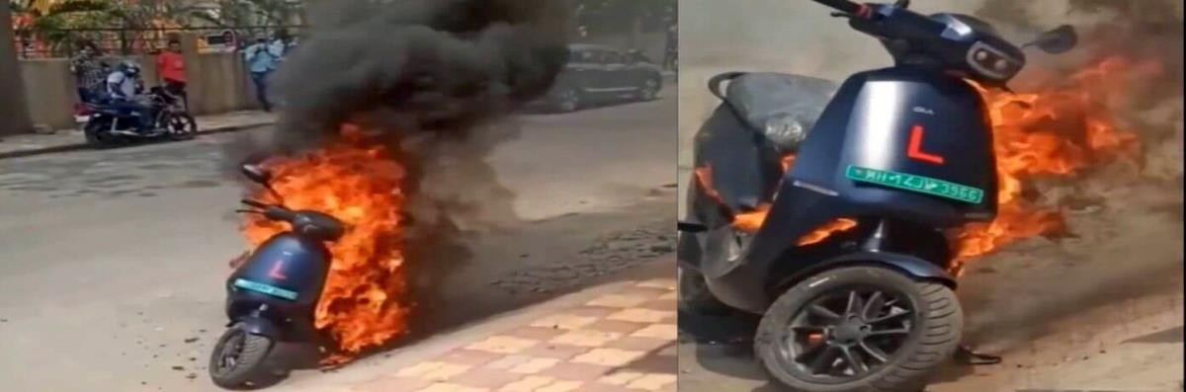

**Fig 1.1 Electric scooter catching fire**

#### Reasons for Electric vehicles catching fire

**Fig 1.2 Reasons for EV fire accidents**

The above table shows different reasons why Electric Vehicles catch fire. We can see many electric bikes catch fire during charging and many incidents occur at charging stations. There are also many other reasons for this as we mentioned improper wiring can also result in this. We can also consider accidents as main reason during collision the disturbances in battery can cause fire.

The objective of this project is to design an automatic fire extinguishing system considering all the reasons mentioned above so that it can prevent from property damage, injuries and improve safety.

#### TYPES OF FIRE

#### Class A – Combustible materials

#### Class B – Flammable liquids

#### Class C – Flammable gases

#### Class D – Burning metals

#### Class K – Cooking oils and fats

#### The five types of fires include: A, B, C, D, and K

#### Class Class A Fire:

#### Fires falling under Class A are caused by common combustible materials like wood, paper, fabric, rubber, and plastic. These fires have relatively low ignition temperatures and will burn out once the fuel or oxygen is depleted. Water and foam agents are commonly employed to extinguish Class A fires.

#### Class B Fire:

#### Class B fires are ignited by flammable liquids or gases such as alcohol, kerosene, paint, gasoline, methane, oil-based coolants, or propane. Water is ineffective for extinguishing Class B fires. Instead, Carbon Dioxide (CO2) or dry chemical agents are typically used to combat these fires.

#### Class C Fire:

#### Class C fires are characterized by live electrical currents or electrical equipment as their source of fuel. These could include electric tools, appliances, motors, and transformers. Such fires are prevalent in industrial settings dealing with energy or electrically powered equipment, such as wind turbines. Water is unsuitable for fighting electrical fires and can worsen the situation. Non-conductive chemical agents, including clean agents, are recommended for extinguishing the flames.

#### Class D Fire:

#### Class D fires involve combustible metals as their fuel source. Common combustible metals include aluminum, lithium, magnesium, potassium, titanium, and zirconium. These types of combustible metals are frequently used in laboratories and manufacturing, making these industries particularly susceptible to Class D fires. Dry powder agents are used to absorb heat and smother the flames by depriving them of oxygen supply.

#### Class K Fire:

#### Class K fires pertain to cooking fires resulting from the combustion of cooking liquids like grease, oil, vegetable fat, or animal fat. Extinguishers with a C rating are suitable for use with fires involving energized electrical equipment. Fire extinguishers containing CO2 are best suited for fires involving electrical equipment.

|  |  |
| --- | --- |
| Nominal Capacity | 24 Ah |
| Capacity | 24 Ah |
| Nominal Voltage | 60 V |
| Maximum Charging Current | 5 Amp |
| Warranty | 2 yrs. |
| Model Name/Number | IQube |
| Minimum Order Quantity | 1 |

**Tab 1.1 Vehicle battery specifications**

#### Fire Suppression agents for Battery fire

The above image shows some of the fire suppression agents and its effectiveness to the fire. From this we can say that different types of agents work effectively for particular battery types and different agents have different suppression effects. In some agents we can also observe re-ignition which might be danger sometimes. So, we have to carefully select the agent that we are going to use.

|  |  |  |  |
| --- | --- | --- | --- |
| **Agent** | **Battery type** | **Release moment** | **Suppression effectiveness** |
| CO2 | LiNi03Co­­­0.2 Mn0.3O2/Graphite | Safety valve is opened | It took 30sec to suppress the fire but reignition was observed during releasing |
| HFC-227ea | LiNi03Co­­­0.2Mn0.3O2/Graphite | Safety valve is opened | It took 22 s to suppress the fire, but re-ignition was observed during the releasing |
| Water mist | LiNi03Co­­­0.2Mn0.3O2/Graphite | Safety valve is opened | No flame appeared |
| Water | Ni oxide/graphite | Temperature of battery up to 650 "C | Extinguished fire within 20 s |
| CO2 | Ni oxide/graphite | Temperature of battery up to 650 "C | Having no effect on reduced the temperature |
| Foam | Ni oxide/graphite | Temperature of battery up to 650 "C | Extinguished fire within 20 s |
| Water mist | Ni oxide/graphite | Temperature of battery up to 650 "C | No effect on reducing the temperature |
| Dry power | Ni oxide/graphite | Temperature of battery up to 650 "C | No effect on reducing the temperature |
| CO2 | LFP | Battery occurs fire | Re-ignition happened |
| HFC-227ea | LFP | Battery occurs fire | Suppressed the fire Explosion and thermal runaway occurred |
| Super fine power | LFP | Battery occurs fire | Explosion and thermal runaway accord |
| CO2 | 13S5P 18650-TYPE LiCoO2 Cell | 15 s after fire occurred | Re-ignition occurred at 10 s after the suppression of open fire |
| Dry powder | 13S5P 18650-TYPE LiCoO2 Cell | 15 s after fire occurred | Re-ignition occurred at 8s after the suppression of open fire |
| 3% AFFF | 13S5P 18650-TYPE LiCoO2 Cell | 15 s after fire occurred | Re-ignition occurred at 45 s after the suppression of open fire |
| Aqueous agent | 5 18650-type UBs | First battery occur TR | None of the cells propagated |
| Gaseous agent | 5 18650-type UBs | First battery occur TR | All of the cells propagated |
| Aerosol | 75 Ah NCM Li-ion pouch cell | Within 5s of the thermal spiking event | Flames are fully suppressed by 10s, but flashover happened |

**Tab 1.2 Different fire suppression agents for different types of batteries**

**CHAPTER 2: LITERATURE REVIEW**

1. **AUTOMATIC FIRE EXTINGUISHING SYSTEM FOR ELECTRIC VEHICLE by Manas Kulkarni in 2022** focuses on designing and using an electric vehicle's automatic fire extinguishing system at a low cost. The fire extinguisher in this system automatically puts out the fire when it detects smoke or flame in the vehicle's fire areas. There are many reasons why electric vehicles can cause fire accidents. The electric vehicle's battery is primarily to blame for the fires. Due to the aforementioned causes, there have been numerous instances in which automobiles caught fire and burned completely. The installation of an automatic fire extinguishing system can increase the level of safety for the vehicle, its occupants, and other participants in traffic while also reducing the potential financial loss caused by a fire.
2. **AUTOMATIC FIRE EXTINGUISHER by Archana. P in 2019** have done the project to replace a traditional fire extinguisher, a combination of LM35smoke sensor and infra-red flame sensor produces a stunning result in public buildings. Utilizing a fire extinguisher system that can put out a fire on its own, without the aid of a human, is also inventive. Property is never more valuable than safety. Additionally, there are situations when the fire may be too big or there may be too much smoke for us to use a traditional extinguisher or we may be too afraid to put it out on our own. But in our automated fire extinguisher, this is not the case. This journal shows the usage of a profitable and practical arrangement good for railroad application at the point. If the fire is identified spontaneously and extinguished automatically, huge losses and property damage can be prevented.

#### 2.1 Objectives

* The primary objective is to investigate and comprehend the causes behind electric vehicle batteries catching fire and identify effective measures to prevent such battery fires in EVs.
* The goal is to develop a sophisticated system capable of detecting fires or smoke in electric vehicles and providing timely warnings to riders, allowing them to move to a safe distance and avoid potential harm. Additionally, the system should be designed to automatically extinguish the fire, thereby minimizing property damage.
* •The aim is to create a system that can be seamlessly integrated into production vehicles, enhancing vehicle safety without compromising their existing characteristics and at a cost-effective price.
* The overarching purpose is to enhance the safety of electric vehicle riders and components while mitigating the risk of battery explosions, which could lead to significant property damage and severe injuries to individuals in close proximity to the vehicle.

**Chapter 3: Components**

**The Automatic fire extinguisher system for EVs has following components**,

* Arduino UNO
* MQ 2 sensor
* RTD Sensor (temperature sensor)
* Solenoid valve
* Pressure cylinder for co2
* IR flame sensor

**3.1 Arduino Uno**

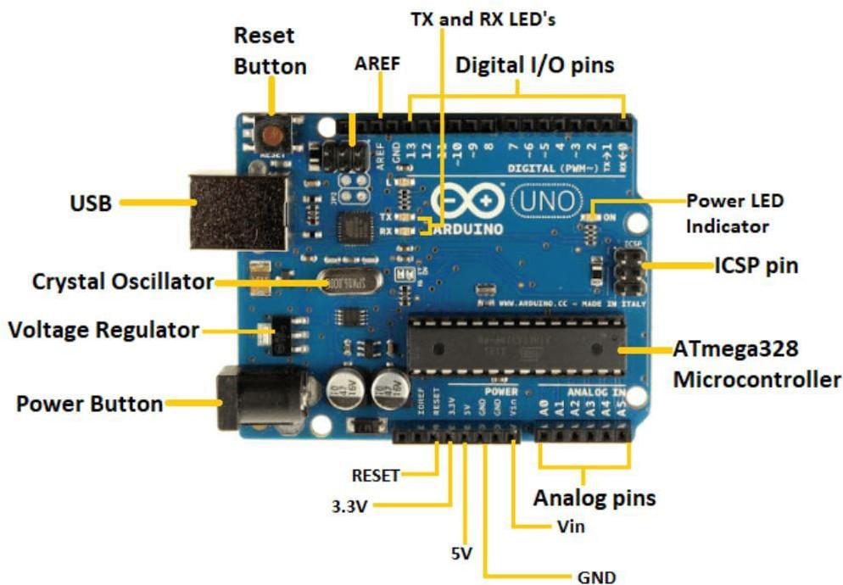 The Arduino Uno is a microcontroller board based on the Microchip ATmega328P microcontroller (MCU) and was developed by Arduino.cc. It is an open-source platform equipped with sets of digital and analog input/output (I/O) pins, enabling connections to various expansion boards (shields) and circuits. The board features 14 digital I/O pins, with six of them capable of PWM (Pulse Width Modulation) output, and 6 analog I/O pins. To program the Arduino Uno, you can use the Arduino IDE (Integrated Development Environment) with a type B USB cable. Power can be supplied through either a USB cable or a barrel connector that supports voltages between 7 and 20 volts, like a rectangular 9-volt battery.

**Figure 3.1 Parts of Arduino UNO**

The Arduino UNO has 14 digital pins, a USB port, a power jack, and an ICSP (In-Circuit Serial Programming) header in addition to 6 analogue pin inputs. The programming language used is called IDE, or integrated development environment. It is compatible with offline and online platforms.

**Each component is explained in detailed view-**

* + - **ATmega328 Microcontroller -** It is a single chip Microcontroller of the Atmel family. The processor code inside it is of 8-bit. It combines Memory (SRAM, EEPROM, and Flash), Analog to Digital Converter, SPI serial ports, I/O lines, registers, timer, external and internal interrupts, and oscillator.
    - **ICSP pin -** The In-Circuit Serial Programming pin allows the user to program using the firmware of the Arduino board.
    - **Digital I/O pins** - The digital pins have the value HIGH or LOW. The pins numbered from D0 to D13 are digital pins.
    - **AREF -** The Analog Reference (AREF) pin is used to feed a reference voltage to the Arduino UNO board from the external power supply.
    - **USB -** It allows the board to connect to the computer. It is essential for the programming of the Arduino UNO board.
    - **GND -** Ground pins. The ground pin acts as a pin with zero voltage.
    - **TX and RX LED's**- The successful flow of data is represented by the lighting of these LED's.
    - **Analog Pins -** The pins numbered from A0 to A5 are analogue pins. The function of Analog pins is to read the analogue sensor used in the connection.

#### 3.2 MQ2 Smoke Sensor

#### 

**Fig 3.2 MQ2 smoke sensor**

The MQ2 smoke sensor, belonging to the family of MQ sensors, operates based on Metal Oxide Semiconductor (MOS) technology. It requires a 5V DC supply and consumes approximately 800mW of power. This sensor is capable of detecting various gases, including smokes, hydrogen, propane, alcohol, methane, carbon monoxide, and LPG, with concentrations ranging from 200 to 10,000 parts per million.

* 1. **RTD sensor**

## RTD Pt100 Temperature Sensor Probe, Jaybva Waterproof Stainless Steel Thermistor Three Wire High Precise Accuracy Range:-50℃ to 200℃ 6.6 Feet Wire : Amazon.in: Industrial & Scientific

## Fig 3.3 RTD sensor

## An RTD (Resistance Temperature Detector) is a temperature sensor that exhibits a change in resistance corresponding to fluctuations in temperature. As the sensor's temperature rises, its resistance also increases. This resistance-temperature relationship is widely understood and remains consistent over time, ensuring repeatability. It's important to note that an RTD functions as a passive device.

## Solenoid Valve

## BX320 1/4″-1″ 2/2 Normally Closed Super High Pressure Solenoid Valve IP65

## Fig 3.4: 160 bar High-Pressure Stainless-Steel Solenoid Valve

**3.4.1 Specifications:**

1. Make/manufacturer: BRANDO
2. Model no: SH
3. Working medium: air, water, gas, liquid, etc
4. Max Working Pressure: 160 bar
5. Seal Material: PTFE
6. Body Material: Stainless Steel 304
7. Port Size: 3/8'', 1/2'', 3/4'', 1''
8. Orifice Size: 1mm to 25mm
9. Operation: Direct Acting (DN1 to 5), Piston Pilot Operated (DN10 to 25)
10. Voltage: 12VDC, 24VDC, 24VAC, 110VAC, 220VAC (50/60Hz)

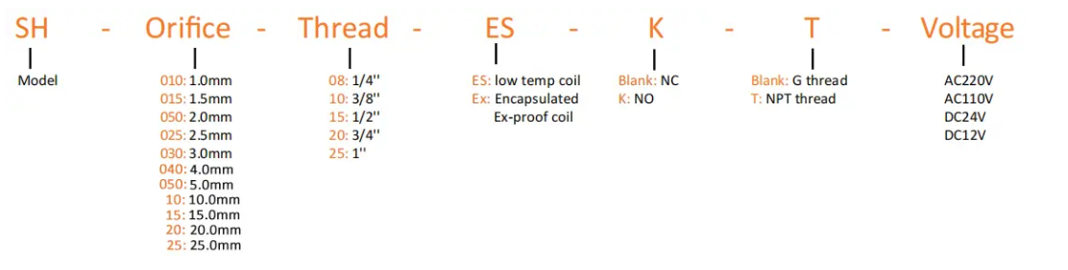**3.4.2 Order code**

## Fig 3.4.1 figure code

## 3.4.3 – Technical Data

## 

## Fig 3.4.2 Technical data

|  |  |  |  |  |  |  |  |
| --- | --- | --- | --- | --- | --- | --- | --- |
| **Model No** | **Orifice Size**  **(mm)** | **Port Size**  **(inch)** | **CV** | **Working Pressure Range**  **(bar)** | | | **Dimension** |
| **Normally Closed** | | **Normally Open** | **Normally Closed** |
| **220VAC** | **24VDC** | **AxBxC (mm)** |
| SH-010ES | 1 | 1/4'', 3/8'' | 0.04 | 0-300 | 0-150 | 0-150 | 44x25x80 |
| SH-015ES | 1.2 | 0.08 | 0-250 | 0-120 | 0-60 |
| SH-020ES | 2 | 0.15 | 0-180 | 0-70 | 0-35 |
| SH-025ES | 2.5 | 0.20 | 0-110 | 0-45 | 0-20 |
| SH-030ES | 3 | 0.25 | 0-80 | 0-40 | 0-15 |
| SH-040ES | 4 | 0.6 | 0-40 | 0-15 | 0-5 |
| SH-050ES | 5 | 0.9 | 0-25 | 0-8 | - |
| SH-10ES | 10 | 3/8'' | 3.5 | 6-160 | 6-120 | 6-50 | 60x55x109 |
| SH-15ES | 15 | 1/2'' | 4.7 | 70x65x119 |
| SH-20ES | 20 | 3/4'' | 7 | 80x74x124 |
| SH-25ES | 25 | 1'' | 11 | 90x87x134 |

## Table 3.1 Dimensions

## Pressure cylinder for Co2

## 

## Fig 3.5.1 Pressure cylinder for Co2

## Take Here are some of the distinctions between bulk low-pressure carbon dioxide and high-pressure canister CO2:

## Material and Weight:CO2 bulk tanks and cylinders are available in various sizes depending on their intended use, and the two most common materials used are aluminum and steel. The weight of these tanks differs based on their material and whether they are empty or filled. Bulk tanks are stationary and typically constructed from 100% stainless steel, and they come in various sizes to suit specific requirements. Their size and capacity offer increased distribution flexibility and reduce the need for frequent deliveries. On the other hand, CO2 canisters or cylinders are high-pressure tanks designed for exchange. They can weigh over 100 lb when empty and up to 200 lb when filled.

**3.6 Prototype design for fire extinguishing system**

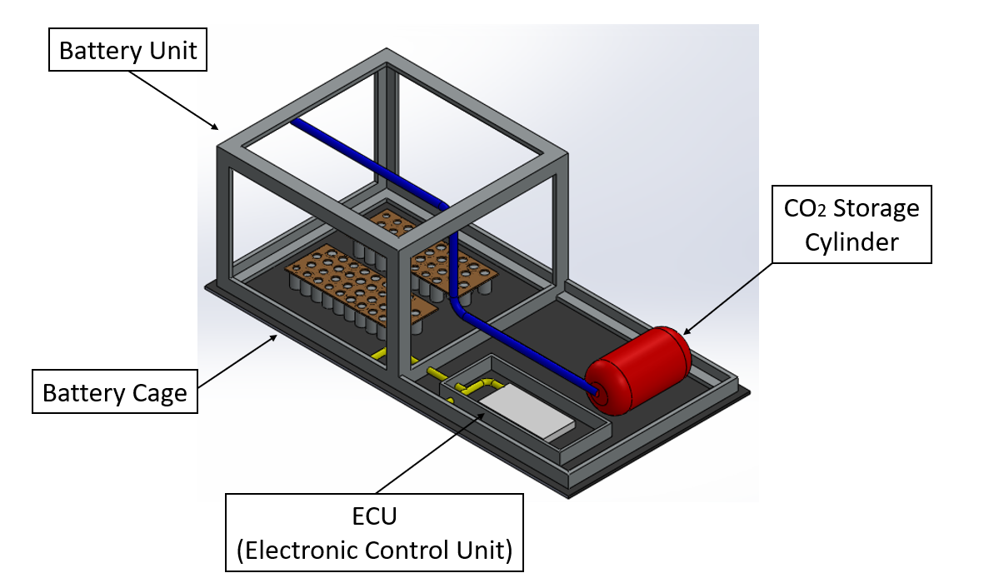

**Fig 3.6.1 Testing Model**

# CHAPTER 4 – METHODOLOGY

# 

**4.1 WORKING**

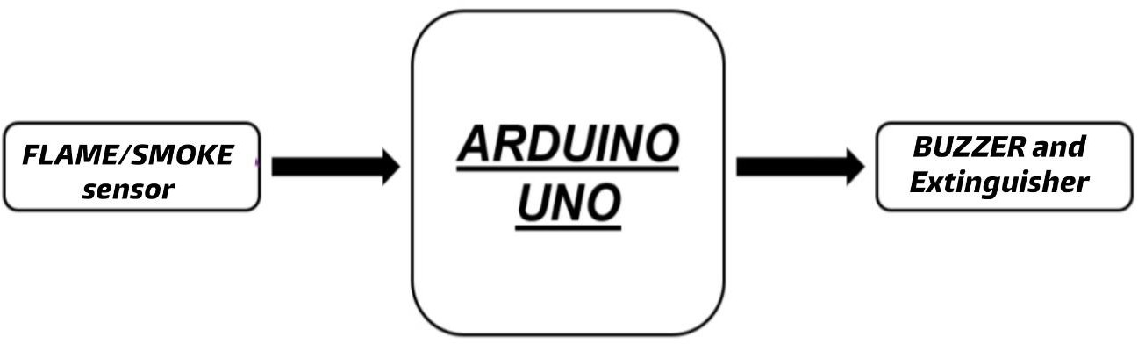

**Fig 4.1 Working principle**

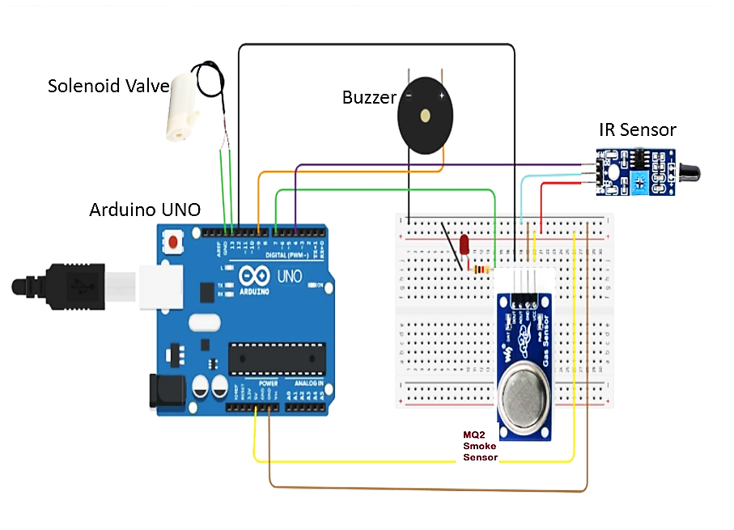**Fig 4.2 Circuit diagram**

The Arduino board offers a total of 14 digital input/output pins, with 6 of them supporting PWM outputs. Additionally, it provides 6 pins for analog input/output. To keep our Arduino program simple and easily comprehensible, we opted to use digital pins to connect the flame and smoke sensors. The Arduino board comes equipped with flash memory, capable of storing uploaded programs, with a capacity of up to 32 KB. We utilized the Arduino IDE software for coding purposes.

Various components, such as the flame sensor, gas sensor, buzzer, and water pump, are connected to the Arduino using jumper cables. These sensors and components are linked to their respective pins, as specified in the program that was uploaded to the Arduino. Power for the Arduino board comes from a laptop, while the other components receive power from the 5V pin on the Arduino

The IR flame sensor and MQ2 gas sensors continuously monitor for the presence of flames or smoke near the battery. If either sensor detects flame or smoke, it sends a value of 1 to the Arduino, indicating the presence of fire or smoke. The Arduino, in turn, triggers the buzzer, and the water pump floods the battery compartment with water until the fire is extinguished.

The design of the automatic fire extinguisher system is tailored for the OLA S1 pro, which features a 3.97kWh Lithium-Ion battery with a curved shape. The structure is constructed using materials capable of withstanding higher temperatures and is less prone to catching fire, unlike steel. The design incorporates breathing holes to facilitate battery cooling. The flame sensor has an effective range of 30cm, and smoke sensors are strategically placed in each corner, approximately 50cm apart from one another, mainly oriented towards the terminals to cover the entire battery area. In the event of flame or smoke detection, the buzzer and solenoid valve are activated, allowing the flow of AVD (Automatic Vapor Dispenser) stored in the S1 pro's boot space. Within 25 seconds of detection, the curved structure is flooded with AVD, preventing further damage to components and avoiding battery explosions.

# CHAPTER 5 - CODING THE SENSOR

## THE PROGRAM CODE

Program code was written using the Arduino IDE software. The errors faced during testing of the code was analyzed and debugged to fit project requirements. First, a basic code for checking the sensibility of our sensors and the correctness of the connections established was run.

The program code used for gesture recognition is as follows:

const int smokePin = A0;

const int irSensorPin = 2;

const int ledPin = 12;

const int buzzerPin = 11;

int smokeThreshold = 400;

void setup() {

pinMode(irSensorPin, INPUT);

pinMode(ledPin, OUTPUT);

pinMode(buzzerPin, OUTPUT);

Serial.begin(9600);

}

void loop() {

int smokeValue = analogRead(smokePin);

Serial.print("Smoke: ");

Serial.println(smokeValue);

if (smokeValue > smokeThreshold)

{

triggerAlarm();

}

int irSensorValue = digitalRead(irSensorPin);

Serial.print("IR Sensor: ");

Serial.println(irSensorValue);

if (irSensorValue == HIGH)

{

triggerAlarm();

}

delay(1000);

}

void triggerAlarm() {

digitalWrite(ledPin, HIGH);

tone(buzzerPin, 1000);

delay(1000);

digitalWrite(ledPin, LOW);

}

# CHAPTER 6-RESULTS AND DISCUSSIONS

# 6.1 RESULTS

# IR sensor output

## Fig 6.1: IR sensor output

## The output of an IR (infrared) sensor can vary significantly depending on its specific type. It may manifest in various forms, such as digital signals that signify the presence or absence of an object, analogue signals that correspond to the intensity of detected infrared radiation, pulse width modulation (PWM) signals that change based on proximity or intensity, or serial communication protocols that offer detailed information, including calibrated values or distance measurements. To successfully integrate an IR sensor with microcontrollers or other electronic components for further processing and decision-making, it is crucial to consult the sensor's datasheet or relevant literature.

## MQ2 sensor output

## Fig 6.2: MQ2 sensor output

## The MQ2 smoke sensor is capable of detecting the presence of smoke or flammable gases within its designated range. Its output typically takes the form of an analog signal, with variations in voltage or current proportional to the quantity of smoke or flammable gases detected. Higher concentrations of smoke or gas lead to an increase in the output signal, while lower concentrations result in a decrease in signal strength. In areas where there is a potential risk of smoke or combustible gases, this analog output can be further processed or utilized in conjunction with microcontrollers or other electronic devices to trigger alarms, activate safety features, or assess the air quality.

## 6.2 DISCUSSIONS

## In the realm of fire suppression, innovative solutions tailored specifically for electric vehicles (EVs) are emerging. These solutions encompass various methods such as foam, inert gases, water mist, and even solid-state extinguishing substances. In comparison to traditional fire suppression systems, these cutting-edge technologies offer numerous advantages, including enhanced effectiveness in extinguishing battery fires, reduced environmental impact, and simplified installation and maintenance processes.

## The integration of fire suppression systems with other vehicle safety features is a possibility in the future. This could involve combining them with existing safety mechanisms like airbags and battery management systems. Such connectivity would enable the fire suppression system to activate automatically in the event of a fire or be manually triggered by the driver or passenger during emergencies.

## As EV technology continues to gain wider adoption, it becomes imperative to establish new criteria for EV fire safety. These standards must account for the diverse range of fire suppression devices available and consider the unique characteristics of EV batteries. By doing so, we can ensure the utmost safety and protection as electric vehicles become more prevalent on the roads.

## CONCLUSIONS

After conducting an extensive review of various literature papers and developing an automatic fire extinguisher system for electric vehicles, we have reached the conclusion that the designed model exhibits excellent capabilities in detecting and extinguishing fires. Moreover, it can be seamlessly integrated into production electric vehicles, thereby significantly reducing the occurrence of electric vehicle fire accidents. The inclusion of infra-red flame sensors and mq2 smoke sensors ensures a swift response to battery fires. In the event of a fire, these sensors will promptly trigger the fire extinguisher system and alarm, effectively containing the fire's spread, minimizing component damage, and reducing the risk of explosions. The alarm system serves as a crucial warning mechanism, alerting riders and bystanders to evacuate to a safe distance before any potential dangers escalate. To ensure continuous monitoring of battery temperature, a temperature sensor module is incorporated. If the battery's temperature exceeds a certain threshold, indicating a high likelihood of fire or explosion, the system takes preventive measures. It immediately disconnects the battery from circuits and charging to prevent any potential fire, and the cooling system is activated to mitigate temperature rise.

While our literature survey identified AVDs as the most efficient fire extinguishing agents for lithium-ion battery fires, we decided not to include them in this project. This decision was made to avoid increasing complexity, programming requirements, and associated component costs. Nonetheless, the designed system with its array of sensors and fire extinguishing mechanisms is proven to be highly effective and addresses the critical need for enhanced fire safety in electric vehicles.

## SCOPE FOR FUTURE WORK

• By enhancing this project, we can incorporate a GSM module to alert the electric vehicle owner in the event of a fire accident, enabling them to take immediate safety precautions.

• To ensure safety, the battery can be housed in a dedicated compartment, isolated from other components. In case of fire or smoke, the battery can be disconnected, and the chamber can be flooded with extinguishing agents to promptly extinguish the fire and minimize damage.

• Implementing a cooling system for electric 2-wheelers will effectively reduce battery temperature and facilitate the development of more advanced battery management systems (BMS).

## REFERENCES

1. David Wagman, powerplant run on Co2, June-2018.
2. Torgrim Log, Peter Cannon-Brookes, Water mist for fire protection of historic buildings and museums, Museum Management and Curatorship, 14(3), pp. 283- 298 (1995)
3. Liao Guangxuan, Huang Xin, Cong Beihua, Qin Jun, Liu Jianghong, Wang Xishi, Progress in water mist fire suppression technology, Journal of University of Science and Technology of China; 36(1), pp. 9- 19 (2006)
4. Wang Xishi, Liao Guangxuan, Qin Jun and Fan Weicheng, Experimental study on effectiveness of extinction of a pool fire with water mist, Journal of Fire Sciences. 20(4), pp. 279-295. (2002)
5. Wu Longbiao,Fang Jun,Xie Qiyuan. Fire detection and information processing[M]. Beijing: Chemical Industry Press, 2006, 264-265(in Chinese)
6. Chen nan. Design of Fire Detection and Control Systems for Intelligent Buildings[M]. Beijing: Tsinghua University Press, 2001, 7: 19-60(in Chinese).

# 

